**GOVERNMENT COLLEGE OF TECHNOLOGY, COIMBATORE**

**Computer Science and Engineering**

**IBM NALAIYATHIRAN**

**Project Design Phase-II**

**Data Flow Diagram & User Stories**

|  |  |
| --- | --- |
| Date | 15 October 2022 |
| Team ID | PNT2022TMID06858 |
| Project Name | Project – Realtime Communication System Powered by AI for Specially Abled. |
| Maximum Marks | 4 Marks |

# Data Flow Diagrams:

A data-flow diagram is a way of representing a flow of data through a process or a system. The DFD also provides information about the outputs and inputs of each entity and the process itself. A data-flow diagram has no control flow there are no decision rules and no loops.

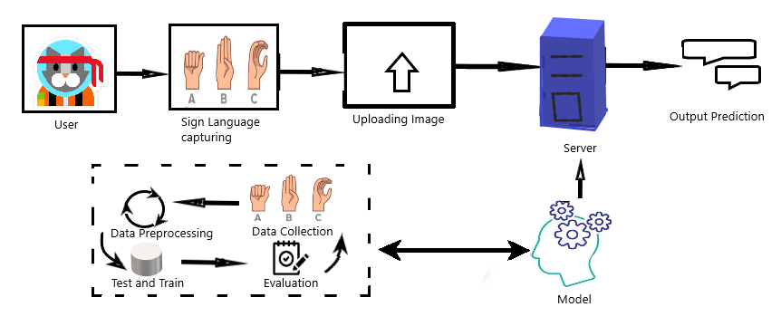

# User Stories

Use the below template to list all the user stories for the product.

|  |  |  |  |  |  |  |
| --- | --- | --- | --- | --- | --- | --- |
| **User Type** | **Functional**  **Requirement (Epic)** | **User**  **Story Number** | **User Story / Task** | **Acceptance criteria** | **Priority** | **Release** |
| Customers (Mobile user) | Registration | USN-1 | User can register for the application by entering their email, password, and confirming their  password. | Users will be able to access their account | High | Sprint-1 |
|  |  | USN-2 | User can register for the application through Google | receiving  confirmation email | Low | Sprint-2 |
|  |  | USN-3 | User can receive confirmation content through email | Registration gets completed here and user can access their account. | High | Sprint-1 |
|  | Login | USN-4 | User can log into the  application by entering email & password |  | High | Sprint-1 |
| Customers(Web user) | Registration | USN-1 | User can register by giving in their email, password and confirmation of password. | User can access their account | High | Sprint-1 |
|  | Login | USN-2 | User can log into the application by entering email &  password |  | High | Sprint-1 |

|  |  |  |  |  |  |  |
| --- | --- | --- | --- | --- | --- | --- |
| **User Type** | **Functional Requirement**  **(Epic)** | **User Story**  **Number** | **User Story / Task** | **Acceptance criteria** | **Priority** | **Release** |
|  | Dashboard |  |  | User can access their Dashboard | Medium | Sprint-2 |
|  | Upload image | USN-3 | Users can upload the sign  Language image for Translating into text format | Users can see the  appropriate text for the sign language | High | Sprint-3 |
| Customer Care Executive | Solution | USN-4 | Suggestions through helpdesk can be used by the users to resolve their queries | Help desk will respond the user with a solution | Medium | Sprint-3 |
| Administrator | Manage | USN-5 | Do It Yourself service for Delivering Everything. | Set of predefined Requirements that must be met to mark a user story  complete | High | Sprint-4 |